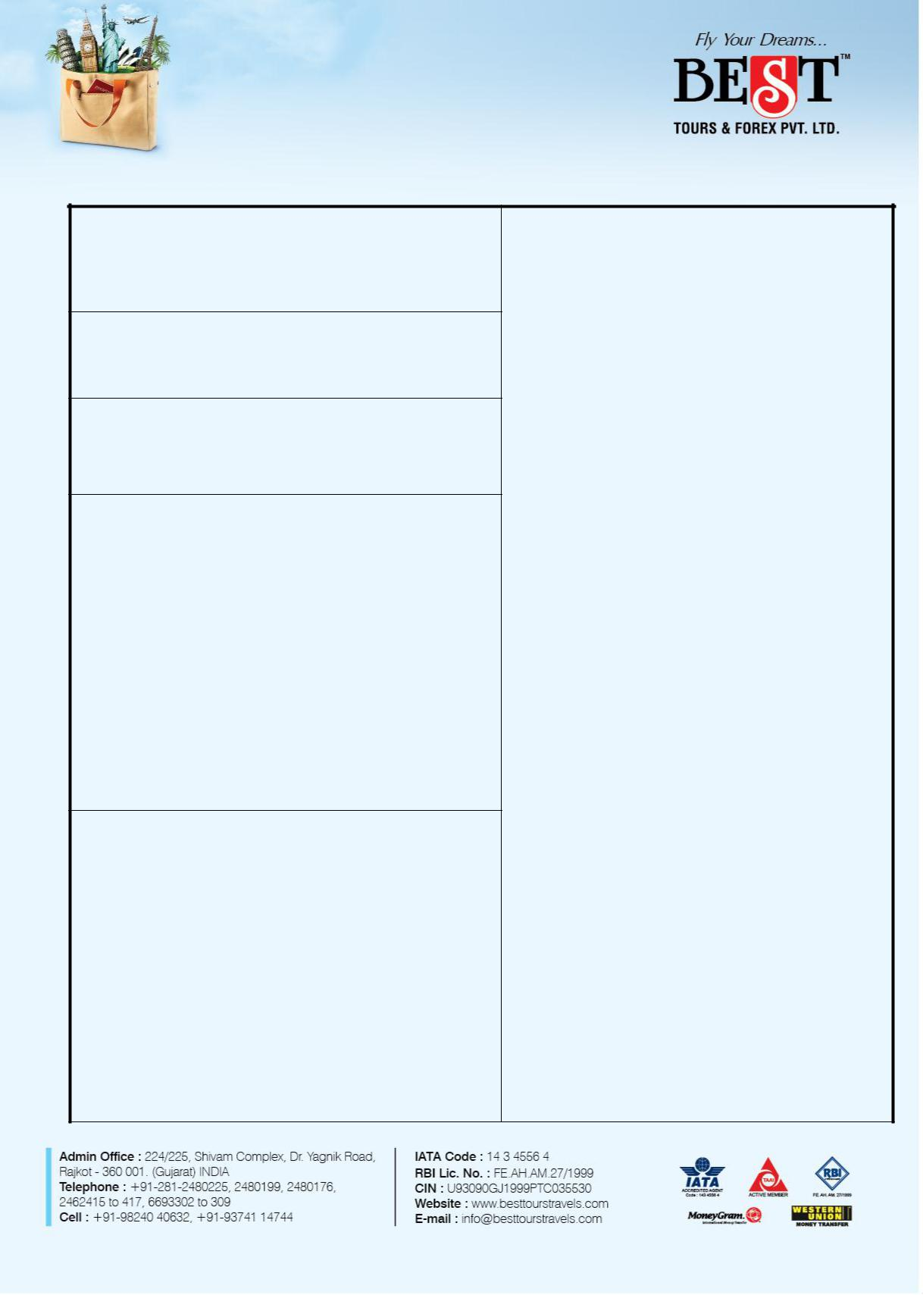**E u r o p e - 1 5 D ay s**

**(Vienna, Klagenfurt, Padova, Milan, Switzerland, Paris, Amsterdam, Frankfurt, Prague)**

**Airline:**

* Economy class Air Ex- Mumbai on Fly Dubai
* All Airlines Taxes
* All tours and transfers on AC Coach

**Meals:**

* 14 Breakfast
* 14 Dinner at Indian Restaurant

**Visa & Overseas Travel Insurance:**

* Schengen Visa
* 15 Days Overseas Travel Insurance

|  |  |
| --- | --- |
| **Hotels :4 Star Hotels** |  |
| **DESTINATION** | **NO OF NIGHTS** |
| Vienna | 01 |
| Kalgenfurt | 01 |
| Padova | 01 |
| Milan | 01 |
| Zurich | 03 |
| Paris | 03 |
| Amsterdam | 02 |
| Frankfurt | 01 |
| Prague | 01 |

**Sightseeings :**

**Bratislava:**

* Orientation Tour

**Vienna**

* Orientation Tour

**Klagenfurt**

* Orientation Tour

**Italy**

* Return Boat Ride to St Marks Square in Venice
* Gondola Ride in Venice
* Orientation Tour of Venice
* Leaning Tower of Pisa (Outside)
* Orientation Tour of Milan

**Switzerland**

* Mt Titlis by cable car and Lunch
* Orientation Tour of Lucerne
* Orientation Tour of Interlaken
* Visit to Rhinefalls (Boat Ride not included)
* Orientation Tour of Zurich

**Paris**

* Seine River Cruise
* Orientation Tour of Paris
* Eiffel Tower (Entry to Level 2)
* Disneyland (01 Day / 01 Park)

**Brussels**

* Orientation Tour

**Amsterdam**

* Orientation Tour of Amsterdam
* Canal Cruise
* Madurodam

**Germany**

* Cologne Cathedral
* Orientation Tour of Frankfurt

**Prague**

* Orientation Tour

**OPTIONAL COST:**

**Switzerland**

* Mt Jungfraujoch by Train to / from

Grindelwald Station and Lunch

**Cost Per Person: INR 15000**

**Paris**

• Lido Show (1100 PM Show)

**Cost Per Person: INR 9950**



**\*\*\*Add on: Service Tax AS APPLICABLE\*\*\***

|  |  |  |  |  |  |  |  |  |  |  |  |  |
| --- | --- | --- | --- | --- | --- | --- | --- | --- | --- | --- | --- | --- |
|  |  | **Currency** |  | **ADULT** | **ADULT** |  | **CHILD** | | **CHILD** |  | **Infant** |  |
| **Tour** |  | **Payment** |  | **(Twin / Triple** | **(Single Sharing)** | | **WITH BED** | | **No BED** |  | **No BED** |  |
|  |  |  | **Sharing)** |  |  |  |  |  |  |  |  |
| **cost** |  |  |  |  |  |  |  |  |  |  |  |
|  | INR |  | 1,95,000 | 292500 |  | 175500 | | 156000 |  | 75,000 |  |
|  |  |  |  |  |  |
|  |  | |  |  |  |  |  |  |  |  |  |  |
| **F l i g h t D e t a i l s :** | | | |  |  |  |  |  |  |  |  |  |
| **D A T E** | |  |  | **S E C T O R** |  | **F L T . N O** | | **D E P .** | **A R R .** | |  |  |
| 1 9 M a y ’ 1 7 | | | | M u m b a i – D u b a i | | F Z 4 4 6 | | 0 5 1 0 H r s 0 6 5 0 H r s | | |  |  |
| 1 9 M a y ’ 1 7 | | | | D u b a i – B r a t i s l a v a | | F Z 7 8 5 | | 0 9 1 0 H r s 1 3 1 0 H r s | | |  |  |
| 0 2 J u n ’ 1 7 | | | | P r a g u e – D u b a i | | F Z 7 8 0 | | 1 3 5 0 H r s 2 1 5 0 H r s | | |  |  |
| 0 2 J u n ’ 1 7 | | | | D u b a i – M u m b a i | | F Z 4 4 5 | | 2 3 3 5 H r s 0 4 1 0 H r s # | | | |  |

**N o t e : T e r m s a n d c o n d i t i o n s a s p e r b o o k i n g f o r m s .**

**Contact # Siddharth Ahya - 9898236194**